Savings and the poor
A better mattress
Mar 11th 2010
From The Economist print edition
Microfinance focuses on lending. Now the industry is turning to deposits
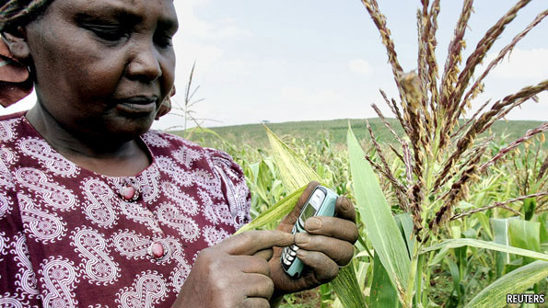

IT IS hard for people in the rich world to imagine what it is like to live on $2 a day. But for those who do, the problem is often not just a low income, but an unpredictable one. Living on $2 a day frequently means living for ten days on $20 earned on a single day. The task of smoothing consumption is made more complicated if there is nowhere to store money safely. In an emergency, richer people might choose between dipping into their savings and borrowing. The choice for the great mass of the unbanked in the developing world is limited to whom to borrow from, often at great cost.
That they can borrow at all is partly due to the rapid growth of microfinance, which specialises in lending small amounts to poor people. Several big microfinance institutions (MFIs) also offer savings accounts: Grameen Bank in Bangladesh is a prominent example. But the industry remains dominated by credit, and the ability to save through an MFI is often linked to customers’ willingness to borrow from it. Of 166 MFIs surveyed in 2009 by the Microfinance Information Exchange, a think-tank, all offered credit but only 27% offered savings products. Advocates of a greater variety of financial services for the poor argue for more balance.
This may be on the horizon. More MFIs are becoming interested in the potential of savings, thanks partly to the global financial crisis. A majority of more than 400 MFI managers surveyed last March by the Consultative Group to Assist the Poor (CGAP), a microfinance group based at the World Bank, said that they had faced liquidity problems during the crisis (see chart). This, together with rising financing costs and exchange-rate fluctuations for those MFIs that rely on external finance, has prompted many “credit-only” MFIs to warm to the idea of funding at least part of their lending activity using local savings.
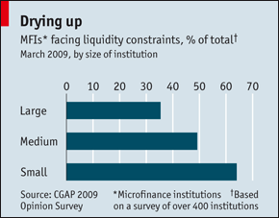

The Bill & Melinda Gates Foundation has thrown its weight behind microsavings. In January it announced grants worth $38m to 18 MFIs in South Asia, Latin America and Africa to encourage them to expand their savings offerings. This is a big deal in an industry which still takes many of its cues from donors. Bob Christen, the foundation’s director of financial services for the poor, says that it sees the grants as a major step to “help broaden the microfinance business model to include savings”.
It will take more than good intentions and a recognition that the poor want places to deposit the money they squirrel away to make microsavings work. Part of the problem with trying to mobilise deposits from poor people is simple economics. It is hard to make a profit from customers who make lots of tiny deposits without massively trimming transaction costs.
The widespread use of mobile phones by poor people in developing countries may provide one answer. People in Kenya, for instance, already use a successful text-message-based service called M-PESA to transfer money electronically to other mobile users. And a new microinsurance scheme uses M-PESA to offer Kenyan farmers protection against bad weather (see article).
But there are challenges for MFIs seeking to enter mobile banking. Ignacio Mas of the Gates Foundation points out that ensuring secure text-message transactions will often require an agreement with a mobile operator, which controls access to the phone’s SIM card. That may be simple in places like Bangladesh, where MFIs also provide mobile services. In others, mobile operators may want to go it alone.
Banks and other financial institutions may also now find it easier to provide branchless banking for the poor. In its simplest form, a bank could appoint someone like a shopkeeper or mobile-airtime reseller as an agent who collects deposits and pays out withdrawals. A business model like this—making use of mobile phones—could massively reduce transaction costs.
For all this to happen, banking regulations in many countries need to become more flexible about who can accept deposits. Timothy Lyman of CGAP says that regulators are getting more comfortable with the idea of banking agents. India, which initially allowed only very few kinds of agents, last year broadened the categories of those eligible. MFIs are also interested in becoming bank agents, especially in places where they are not legally permitted to take deposits. Cashpor, an Indian MFI working with the Grameen Foundation, intends to use some of the Gates Foundation’s money to partner with a savings bank, taking the bank’s products to the customers it already has.
If better technology and more flexible regulation are necessary for microsavings to work, they are still not sufficient. The final step is designing products that work for poor people. Several MFIs that are getting Gates Foundation money are experimenting with savings accounts that feature commitments to make regular deposits, something many people find attractive. Providers looking to base some lending on deposits also like commitment products, since the money is locked in for some time. Marcia Brown of ACCION International, one of the Gates grantees, says that accounts designated as being for a particular purpose, such as children’s school fees, are likely to be part of the product mix.
Sendhil Mullainathan, a Harvard economist, points out that there is often a big gap between what people say they’d like to save and what they end up saving. Saving, he argues, is often “what didn’t happen”—the accumulation of decisions not to consume. Consumption, by contrast, is an active decision to buy something. One product he is testing in India involves collaborating with banking agents to sell “savings cards” in shops, so that saving becomes an active purchase and can compete with other impulse buys. With luck these kinds of innovations can help the poor use their own savings to make life just a little more predictable.

